ALTERA Cycloen IV A-ESTF CORE Board

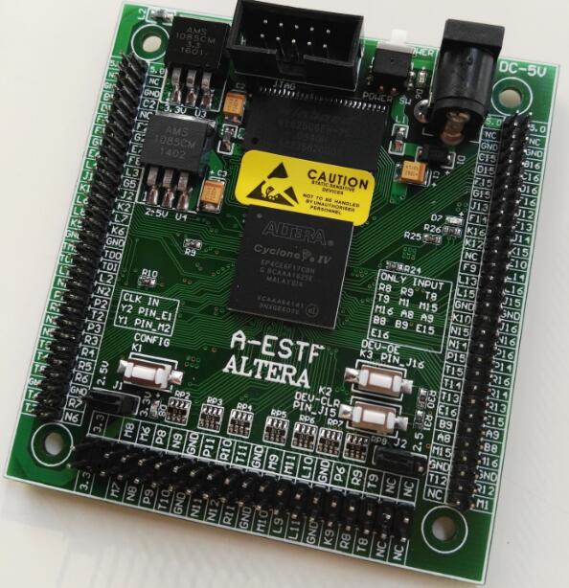

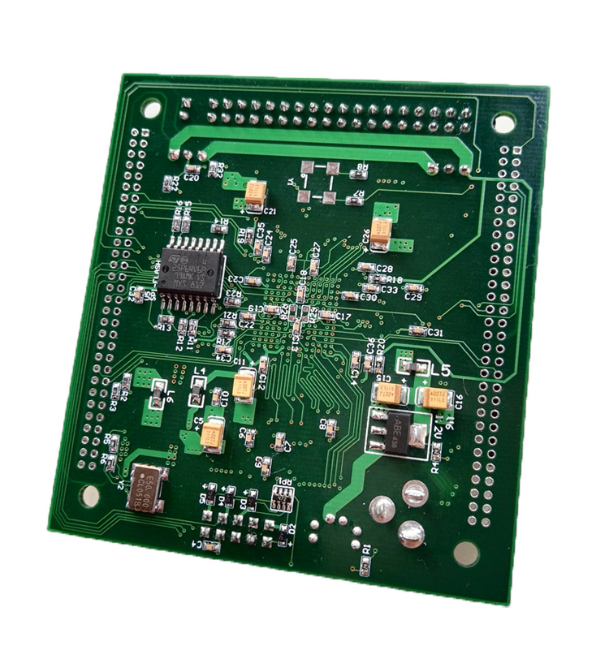

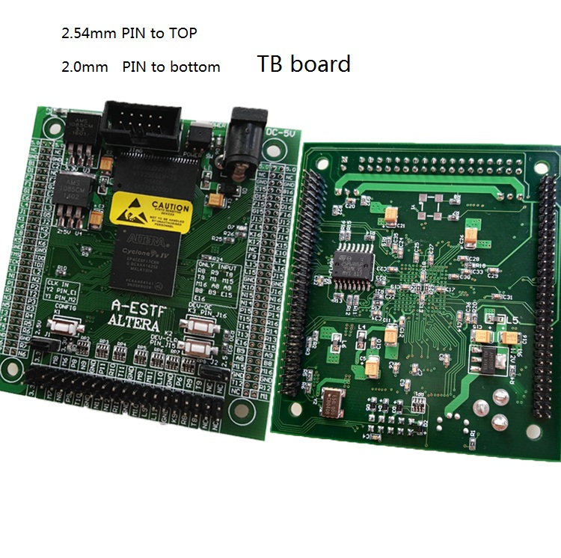

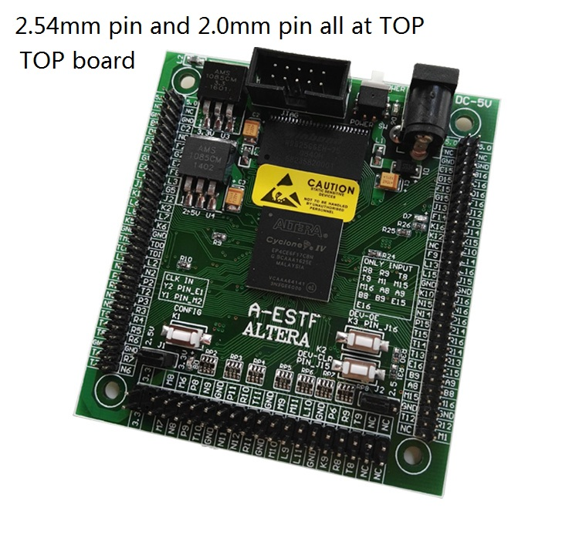

Board DC5V input
FPGA:EP4CE15/E10/E6F17C8N
SDRAM:256M bit
SPI FLASH configer : 64M bit
50M CLK input
2 key input .key2 ,key3
one key re_configer FPGA
one LED output , use test board display.
BANK1, BANK2, BANK3 VCCIO can set 2.5V or 3.3V,if you want to chang VCCIO,pls power off
BANK4, BANK5, BANK6 VCCIO can set 2.5V or 3.3V,if you want to chang VCCIO,pls power off
board output 106 PINS , can output or input. have 13 PINs only input CLK.
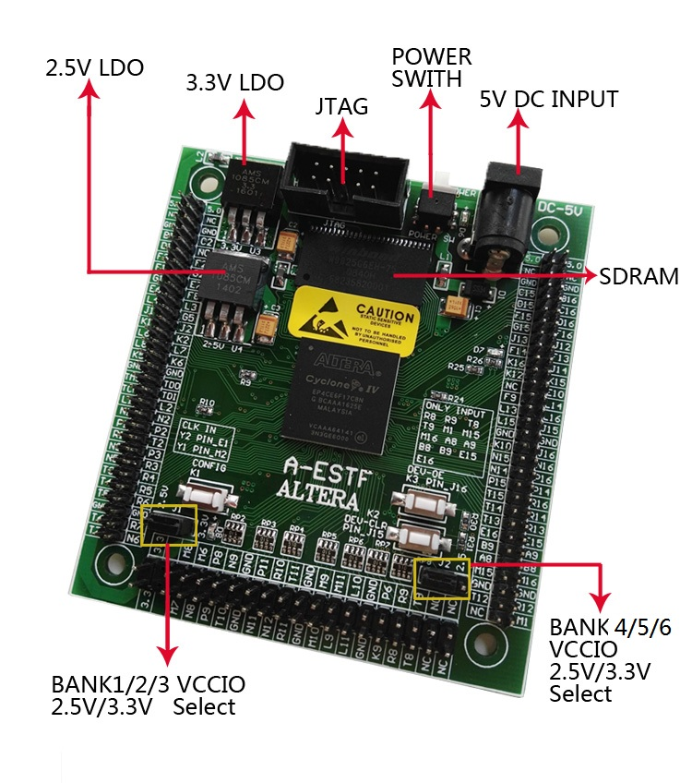
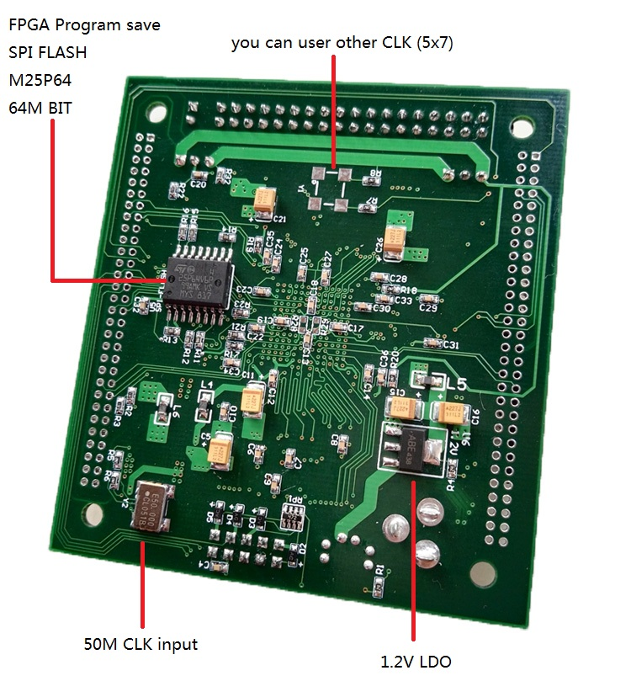
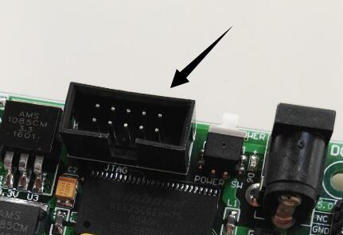
From JTAG download SOF file to FPGA chip,or download jic file to SPI FLASH M25P64 or EPCS 64 save FPGA program .

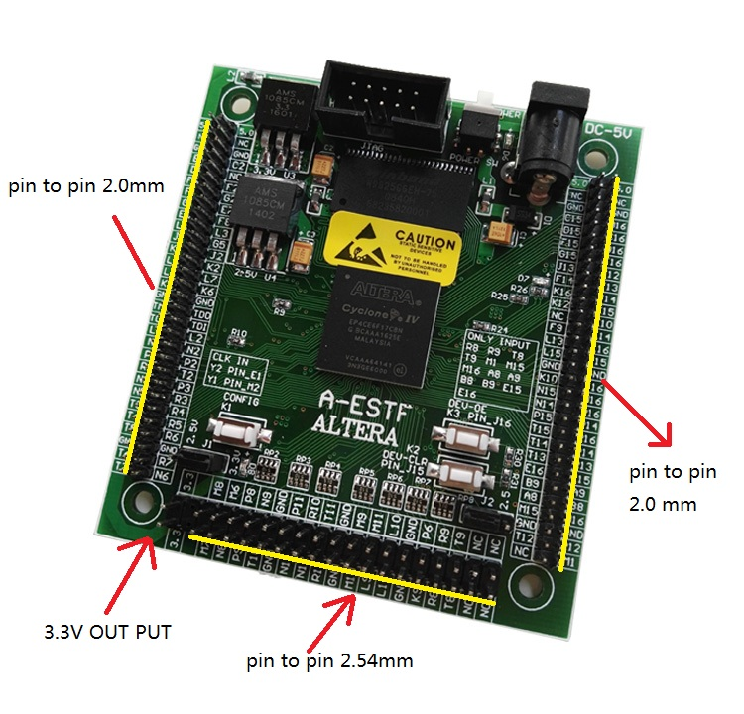
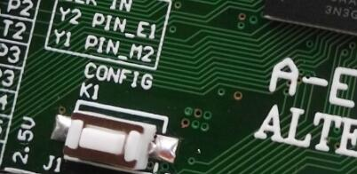
K1 can.t be to program ， but if you press once the key1, FPGA will reload program from SPI flash M25P64.
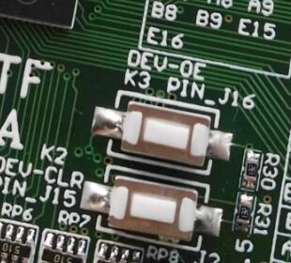
K2 , K3 can be program. Steady state is 1(high),mean FPGA PIN_J15 and PIN_J16 high level. If you press down the K2 or K3 , the FPGA PIN_J15 or PIN_J16 is 0(low level) .

K2 have secondary function is DEV_CLR(global reset).I/O or global clear input. In QuartusII, if you choose the Enable Device-Wide Reset (DEV_CLRn) this function. This is the global zero. When this pin is set low, all registers are cleared. This foot will not affect the JTAG boundary scan or programmed operation.

K3 have secondary function is DEV_OE(global Enable ,Enable Device-wideoutput Enable).I/O pin or global I/O enable pin. In the Quartus II software can enable the DEV_OE option (Enable Device-wideoutput Enable), if can make this a function, this pin can be enabled when the global I/O feet, this foot function is, if it is set low, all I/O into three states.
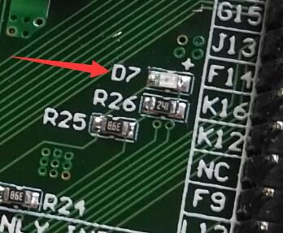
Led7,When FPGA from SPI EPCS loader, LED7 will light , if loader ok and FPGA runing , LED7 will don.t light.
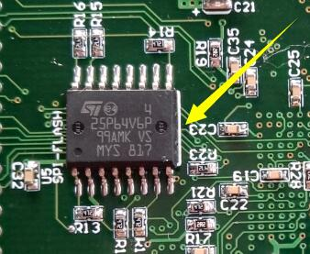
Board SPI FLASH M25P64 save FPGA program.M25P64 like the same EPCS64
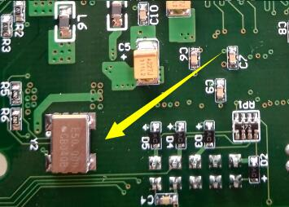
CLK50M ,from FPGA E1 input, you can use PLL get other frequency, for example 10M 25M 100M 200M etc.
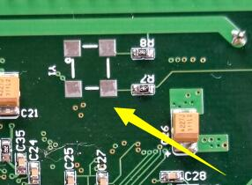
Have other don.t solder(PIN_M2), you can use a 5X7 volume Crystal oscillator solder on.
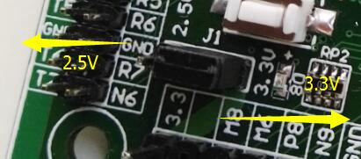
J1 is bank1 bank2 bank3 VCCIO, can set 2.5V or 3.3V
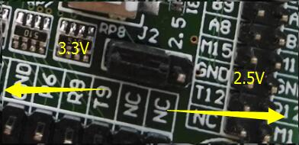
J2 is bank4 bank5 bank6 VCCIO, can set 2.5V or 3.3V
if you want to chang VCCIO,pls power off
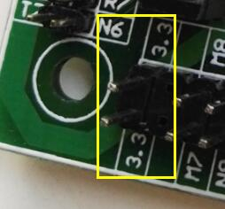Board have 3.3V output.
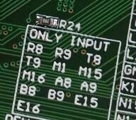
board have 13 PINS only can input
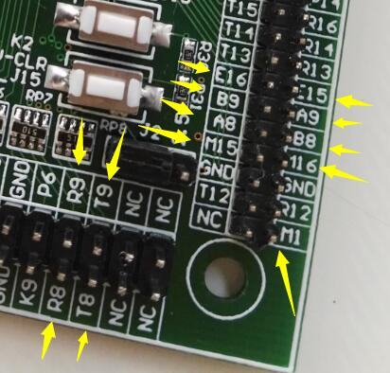

Please note TCK TMS TDO TDI.
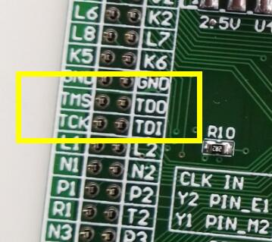
NC is not connect any FPGA pin.
